**RESTAURANT MANAGEMENT**

**SYSTEM**

Submitted to

Dr. Xumin Liu

On May 05th

,

2013

By

Ankan Mookherjee

CS 771

Rochester Institute of Technology

**ABSTRACT**

In the today world customer satisfaction is the key to success for any business. In a restaurant, the traditional hand-waving method for calling services is inefficient often leading to many complaints and similarly keeping track of the restaurant customers billed items and, inventory management for the business would be a tedious job if we use the traditional method of tracking it using paper works. The proposed Restaurant Management System increases operational efficiency through use of a statistical data processing unit. The model has been divided in to 3 major features. Firstly, it handles front office and patron management to incorporate booking reservation tables for customers, ordering food and patrons paying the food bills. Secondly, inventory management system which keeps tracks of food product items. Thirdly, our software model maintains the vendor list and it also employee management, which keeps track of total number of hours worked by an employee and their hourly rate. A data processing unit allows managers and owners to easily monitor restaurant functions and employee progress.

II

**TABLE OF CONTENTS**

ABSTRACT .............................................................................................................................II TABLE OF CONTENTS .......................................................................................................... ..III LIST OF FIGURES .................................................................................................................... V

1.0 INTRODUCTION ................................................................................................................. 1

2.0 SYSTEM DESIGN ............................................................................................................... 2

3.0 HARDWARE and SOFTWARE DESIGN REQUIREMENT…………………………………………………………… 3

*3.1* HARDWARE DESIGN REQUIREMENTS ........................................................................... . 3

*3.2* SOFTWARE DESIGN REQUIREMENT ........................................................................... . 3

*3*.3 SOFTWARE ARCHITECTURE ......................................................................................... . 3

*3*.3.1 DATABASE IMPLEMENTATION …………….………………………………………………………………. 3

*3*.3.2 GRAPHICS USER INTERFACE ………………..………………………………………………………………. 3

ENTITY RELATIONSHIP DIAGRAM .……………………………………………………………………………………….……. 4

DATABASE DESIGN…………………………………………………………………………………………………………….……… 5

5.0 FUNCTIONAL REQUIREMENTS...........................................................................................6

*5.1* FUNCTIONALITIES OF RESTAURANT MANAGEMENT SYSTEM ........................................6

*5.2* PATRON RESERVATION SYSTEM, FOOD ORDER AND BILLING ............................................6

*5.3* RESERVATION SYSTEM INTERFACE.................................................................................6

*5.3.1* REQUEST FOR NEW RESERVATION ........................................................................7

*5.3.2* ORDERING AND TRACKING FOOD ITEMS.............................................................8

*5.3.3* GENERATING THE BILLS .....................................................................................9

*5.4* MANAGING MENU ITEMS – ADD, DELETE AND EDIT MENU………………………….10

*5.4.1* ADD NEW MENU ITEMS…………………………………………………………………………………………… 10

*5.4.2* DELETE A MENU ITEMS………………………………………………………………………………………………10

*5.4.3* EDIT A MENU ITEMS…………………………………………………………………………………………… 11

*5.5* MANAGING SUPPLIERS – ADD, DELETE AND EDIT SUPPLIERS…………….………………………… 12

*5.5.1* ADD NEW SUPPLIER DETAILS ITEMS……………………………………….………………..………… 12

*5.5.2* DELETE THE SUPPLIER ITEMS………………….…………………………………………………..……… 12

*5.5.3* EDIT THE SUPPLIER`S DETAILS……………….…………………………………………………………… 13

*5.6* EMPLOYEE MANAGEMENT – ADD, DELETE AND EDIT EMPLOYEE DETAILS…..……………… 14

*5.6.1* ADD NEW EMPLOYEE DETAILS……………………………….………………………………..………… 14

*5.6.2* DELETE THE EMPLOYEE DETAILS……………………………………………….………………..……… 14

*5.7* EDIT THE EMPLOYER’S DETAILS……………………………………..…………………………………… 15

PRODUCT MANAGEMENT – ADD, DELETE AND EDIT PRODUCT DETAILS….….….…………… 16

*5.7.1* ADD NEW PRODUCT DETAILS………………………………………………….……..….…………….… 16

*5.7.2* DELETE THE PRODUCT DETAILS…………………………………………….………….………………… 16

*5.7.3* PURCHASE THE PRODUCT DETAILS……………………………………..…………..….……………… 17

6.0 TESTING ......................................................................................................................... 18

*6.1* FRONT END INTERFACE TESTING…………………………………………………………………………… 18

*6.2* BACK END INTERFACE TESTING .............................................................................. 18

*6.3* INTEGRATION TESTING ......................................................................................... 18

8.0 FUTURE SCOPE ................................................................................................................ 19

IV

**LIST OF FIGURES**

Figure 1.0: ER Diagram of Restaurant Management System……………………………………………… P.4

Figure 2.0: Restaurant Management System main page …………………………………………………… P.4

Figure 2.1: Reservation of new table for patron ………………………………………………………………… P.7

Figure 2.2: Patron food order tracking …………….………………………………………………………………… P.7

Figure 2.3: Patron food expense bill ...…………….………………………………………………………………… P.8

Figure 3.0: Adding new menu food item ………….………………………………………………………………… P.9

Figure 3.1: Delete food menu item ………………….………………………………………………………………… P.10

Figure 3.2: Edit food menu item ………..…………….………………………………………………………………… P.10

Figure 4.0: Adding Suppliers …………………………….………………………………………………………………… P.11

Figure 4.1: Delete Suppliers ………….………………….………………………………………………………………… P.12

Figure 4.2: Editing Suppliers ………….………………….………………………………………………………………… P.12

Figure 4.1: Delete Suppliers ………….………………….………………………………………………………………… P.13

Figure 5.0: Adding new Employee details….……….………………………………………………………………… P.14

Figure 5.1: Delete Employee details.………………….………………………………………………………………… P.14

Figure 5.2: Delete Employee details.………………….………………………………………………………………… P.15

Figure 6.0: Add Product details……….………………….………………………………………………………………… P.16

Figure 6.2: Purchase Product details….……………….………………………………………………………………… P.16

**1.0 INTRODUCTION**

If we consider restaurants there are so many activities that take place which needs to tracking and managed for overall efficiency of the system. Some of the tasks are the reservation of table for the patrons, tracking the food items ordered by patrons and generating bills. The other major tasks would be like inventory management to keep track of the items needs to prepare the food, and other inventory items needs to run the business like tissue papers, cutting boards, knife etc. Restaurant`s have employees to run the business, they need to be managed, track their working hours and manage the payroll system for them. Keep these in our mind we have developed an application.

The manager or supervisor plays one of the important roles in overall efficiency of the Restaurant or food management system. The restaurant management is a tough and has complex tasks that needs much work and cares to work on. To easy the manger`s or supervisors

of the food management system we have developed a standalone application with a simple, user friendly Graphics User Interface (GUI) to serve the purpose.

The application is called Restaurant Management System which handles the reservations of the tables, employee management, and keep track of inventory of a restaurant. This application could be used by restaurant managers and owners to keep reservations, menu, and re-order

food, track vegetables, condiments supply, etc., it can also be used to calculate revenues and pay

employee salary. A restaurant has a lot of information that can be contained within the database

management system and some of the sets of data we identified are reservations, employee

human resource management, menu, patron, invoice (check and vendor invoice) and food stock

pile.

1

**2.0 SYSTEM DESIGN**

Restaurant Application System is specifically made to increase efficiency of the restaurant with Main Dispatcher software program. Reservations of tables can be made with having to worry about manually checking tables are free or not. The application keeps tracks of the reservations table and tracking customer arriving and leaving the place after having food. It also keeps track of employee time sheet management and gives easy accesses for manager or supervisors to modify the details on the fly.

The application might be useful for the restaurant supervisors or managers to use this Graphic User Interface based software which is supported by a relational database structure at the back end and windows based application as the front end. The connection between the front end and back end is provided using the JDBC connection. The application is developed as a user friendly application which shows the flow in the system and which helps to manage the restaurant for the supervisors or managers from the point a patron enters

the restaurant and to the point the patrons leaves the restaurant. It also deals with day to

day running and functioning of the restaurant like employee management and inventory management system.

The application is broadly categorized into three parts. The first part is front office and patron management. The manager would start with entering the details of the patron to the restaurant. This would be according to the availability and reservations scheme. The patron would then order some dishes from the menu which would be served by the waiters. Finally the patrons would pay the bill and leave the restaurant causing the money paid to be added to the list of revenues. Second part of the database and application deals with inventory check mechanism. If a certain vegetable, condiment or meat item decreases beyond a certain check point then an employee can reorder amount from the vendor. The reorder

amount is kept and when the fresh stock is received it is added to old stock. It also maintains balance sheet for employee management. This would be used to calculate the total hours worked by an employee and salary accounted for according to the hourly rate.

2

**3.0 HARDWARE & SOFTWARE DESIGN REQUIREMENT, & SOFTWARE ARCHITECTURE**

**3.1 HARDWARE DESIGN REQUIREMENTS**: - The hardware requirements to run the application are simple it can be used on any stand alone or network based machine; the system might be Desktop, Laptop, Netbook, NettApp, or a Tablet.

**3.2 SOFTWARE DESIGN REQUIREMENT**: - The software requirement to run the application are as follows, it might be run on Windows XP or higher version of family of windows based operating system.

**3.3 SOFTWARE ARCHITECTURE**

**3.3.1** DATABASE IMPLEMENTED – MSSQL SERVER 2012

**3.3.2** GRAPHICS USER INTERFACE – C# 4.0, Windows

Presentation Foundation

**3.3.3** ID – Visual Studio 2012

3

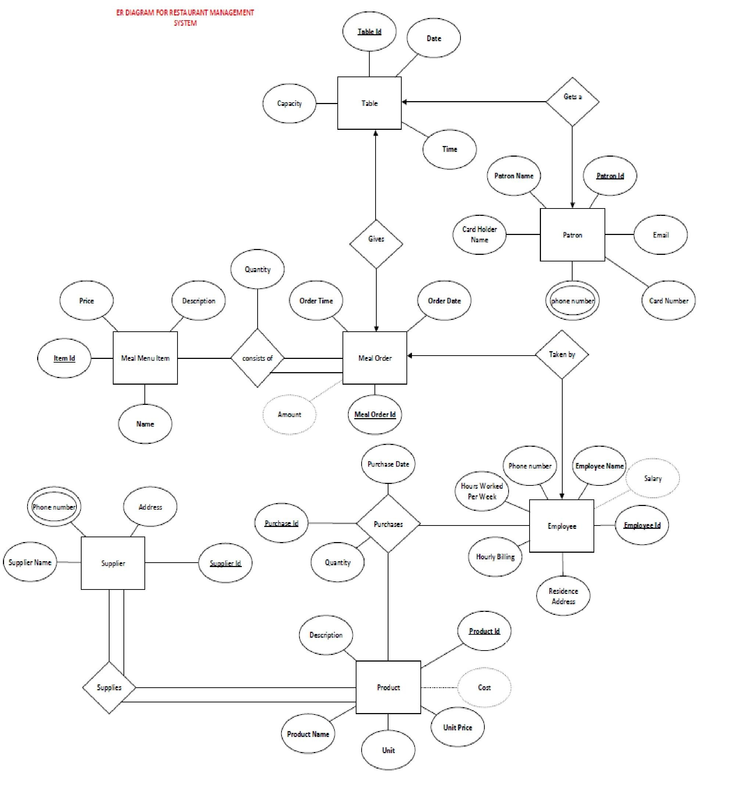

**ER Diagram**

**Figure 1.0:** ER Diagram of Restaurant Management System

**DATABASE DIAGRAM**

|  |  |  |  |  |
| --- | --- | --- | --- | --- |
|  | **Purchase** | | |  |
|  |  | PurchaseID |  |  |
|  |  | ProductID |  |
|  | EmpID |  |
|  | Quantity |  |
|  | PurchaseDate |  |
|  | | |  |
|  | | | | |

**Product**

|  |  |  |  |  |
| --- | --- | --- | --- | --- |
|  |  | ProductID | |  |
|  |  | ProductName | |  |
|  |  | Unit | |  |
|  |  | Amount | |  |
|  |  | UnitPrice | |  |
|  |  | TotalCost | |  |
|  |  | Description |  |  |

**Employee** EmpID Name

[Hourly Billing] HoursPerWeek PhoneNumber ResidenceAddresss

Salary

**Supplies**

SupplierID

ProductID

**OrderTaken**

MealOrderID

EmpID

**Supplier**

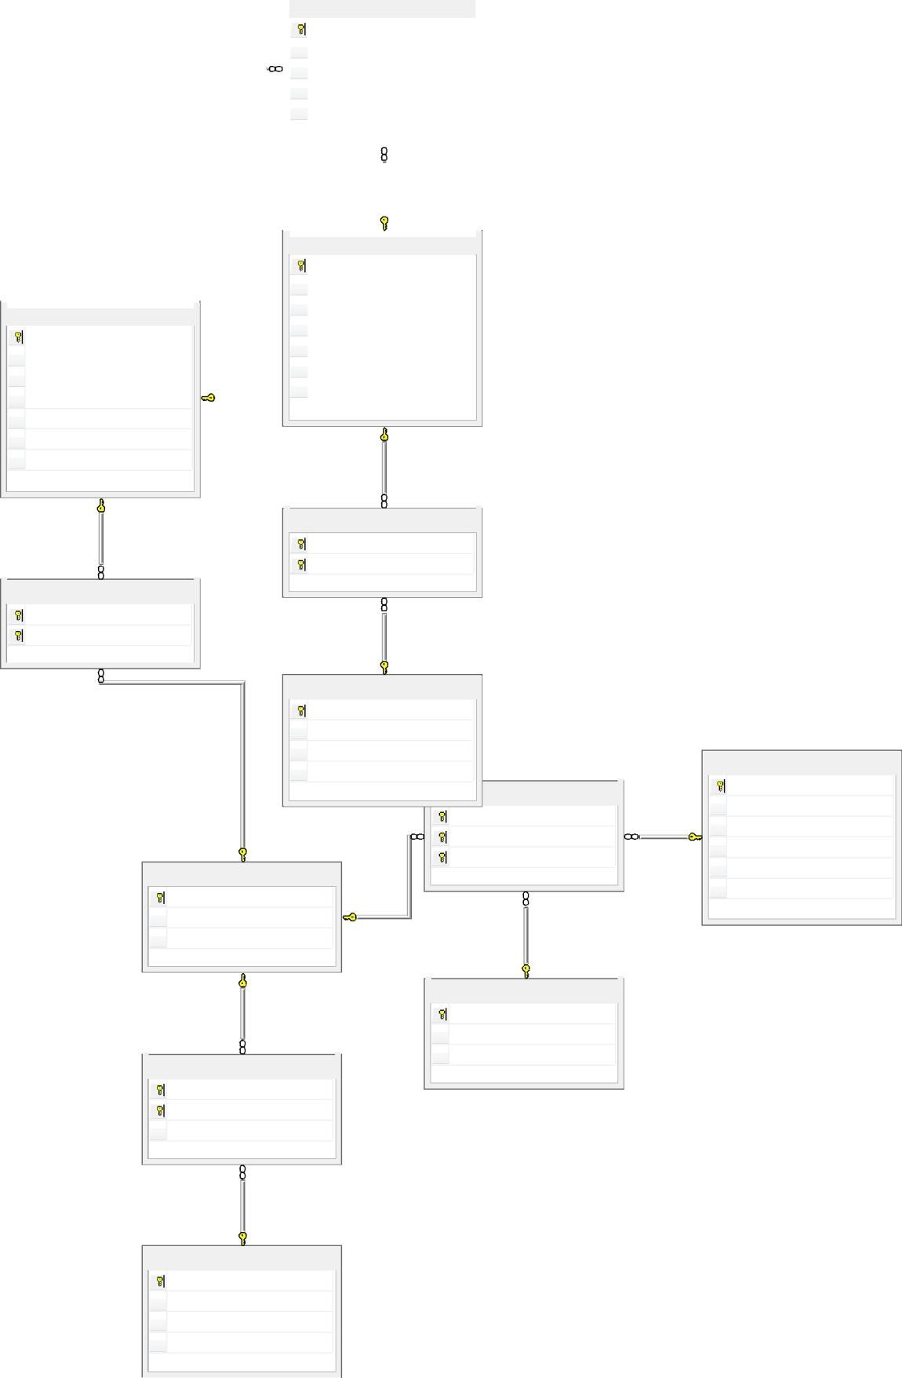

SupplierID SupplierName PhoneNumber

Address **Patron**

PatronID

**PatronGIVESOrder** PatronName

TableID

**MealOrder**

MealOrderID BillAmount

Time

PatronID MealOrderID

Email

CardHolderName [Credit Card Number] PhoneNumber

**OrderedItem**

MealOrderID ItemID Quantity

**Menu**

ItemID ItemName Price Description

**Table**

TableID DateTime Capacity

**4.0 FUNCTIONAL REQUIREMENTS**

**4.2 FUNCTIONALITIES OF RESTAURANT MANAGEMENT SYSTEM**

The application we have developed is the Restaurant Management System which could be used in restaurants to keep track of the reservations of tables, tracking food items

ordered by patrons, and generating bills. The second part would be tracking the employee work sheet management. The third part would be product management. The fourth part would be inventory management. Along with the inventory management if certain food item decreases beyond a certain check point then it would immediately triggers a reorder amount from the vendor.

**4.2 Patron reservation system, food order and billing management**

The main interface of the application is shown as below, using these application restaurant owners, supervisors or mangers can use this application to keep track of employee records, by adding, deleting and editing the employee’s details and time sheet management for the same. It can also be used in the front desk to book the reservation of the table for the patrons. Lets us explain one by in details:

**a. Reserve New Table:** This is the interface where front desk can book the reservation table for the patrons. Track the food items ordered by the patrons and paying the bills.

**b. Add Menu:** This is the interface where the new menu items can be added to the list.

**c. Remove Menu:** This is the interface to remove the menu items for the list.

**d. Edit Menu:** This is the interface to edit the items of the menu list.

**e. Add Supplier:** This is the interface to add new supplier details.

**f. Remove Supplier:** This is the interface to remove the supplier details.

**g. Edit Supplier:** This is the interface to edit the Supplier details.

**h. Add Employee:** This is the interface to add new Employee details.

**i. Remove Employee:** This is the interface to remove the Employee details.

**j. Edit Employee:** This is the interface to edit the Employee details.

**k. Add Product:** This is the interface to add new Product details.

l. **Remove Product:** This is the interface to remove the Product details. m. **Edit Product:** This is the interface to edit the Product details.

6

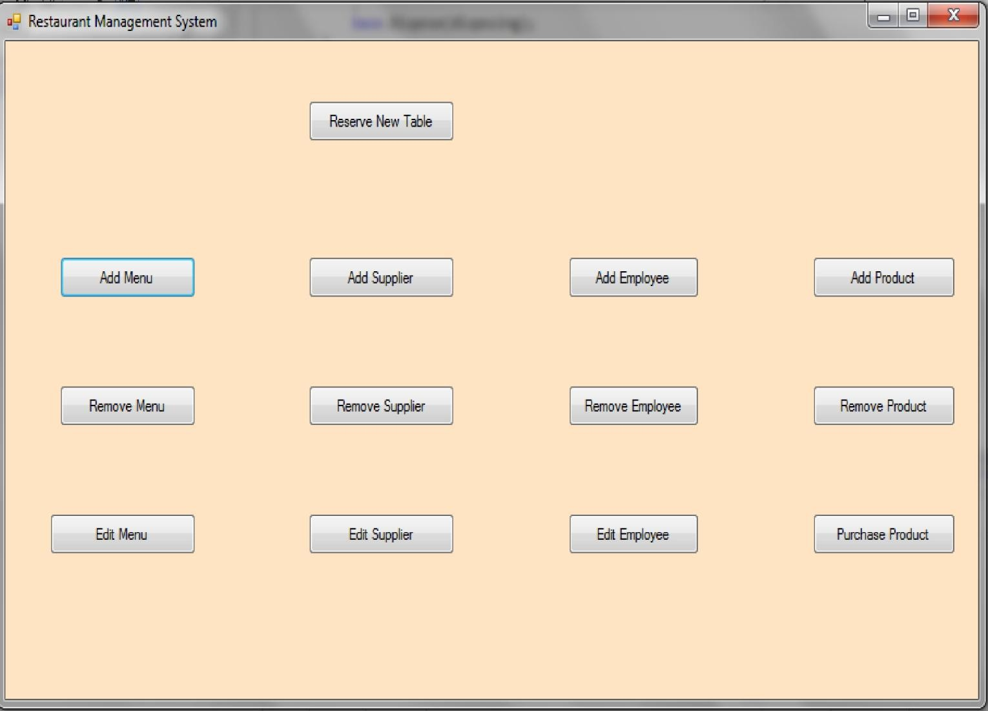

**FIGURE 2.0: Restaurant Management System main page.**

**4.3 Reservation System Interface**

**4.3.1 Request for new reservation:** As shown in the fig 2.1 below this is the interface to add the patron details to reserve the tables, it can be used by front desk to book the table by adding the Patron name, name on credit card, Credit card number, email id, phone number, and capacity requested.

7

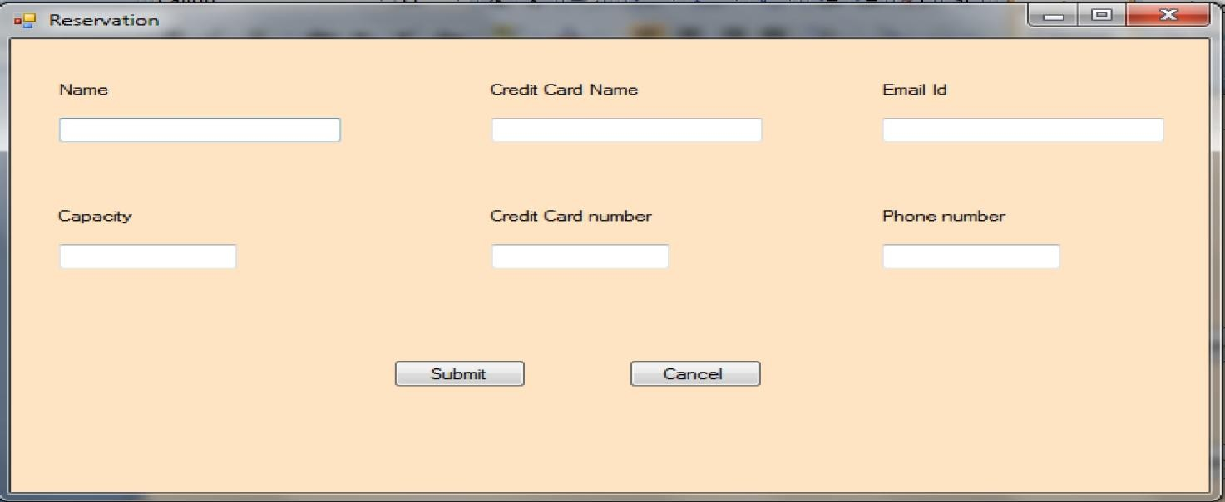

**FIGURE 2.1: Reservation of new table for patron.**

**4.3.2 Ordering and tracking food items:** The food ordered by the patron will be tracked as shown below by adding the details of the quantity of the orders, this is also mapped to the waiter`s name for tracking purpose.

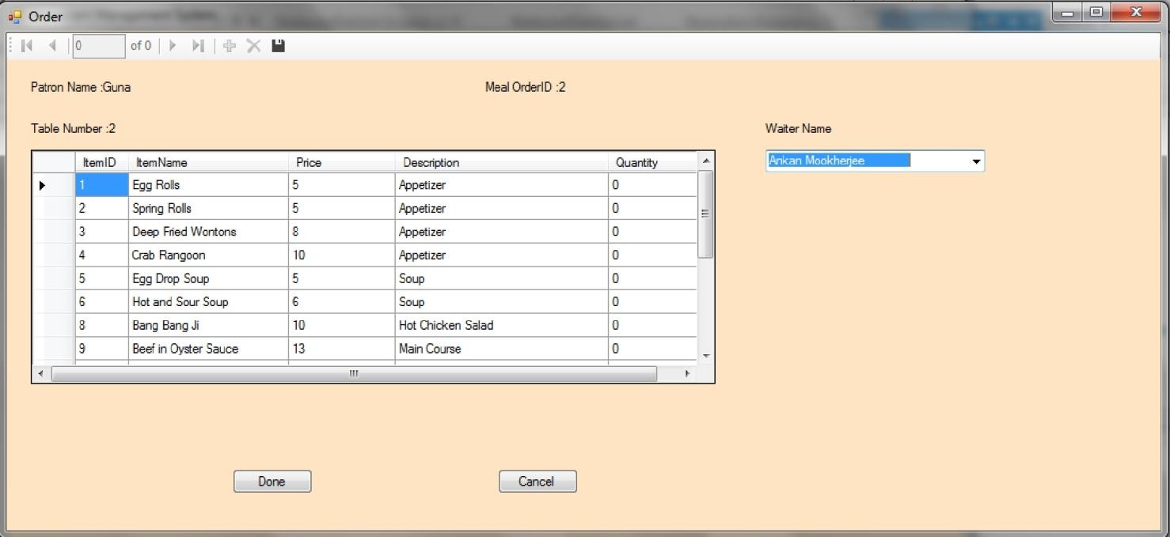

**FIGURE 2.2: Patron food order tracking.**

**4.3.3 Generating the bills:** Once the order`s are served and patrons enjoyed their food, it’s the time to generate the bills. The below interface would generate the bill and we can add the tips details to the final bill.

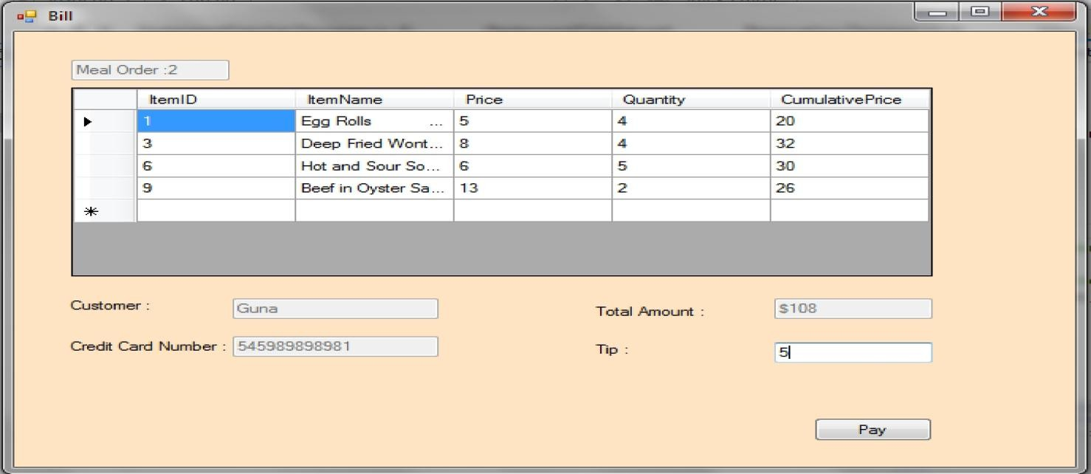

**FIGURE 2.3: Patron food expense bill.**

**4.4 Managing Menu items – Add, Delete and Edit Menu**

In our application we keep track of the menu items, it supports adding new menu items to the application, edit the menu and delete the menu items as needed.

**4.4.1: Add new menu items:** The below is the interface to add the new menu items to the application as shown in the figure 3.0. Manager or supervisors can add the new menu item with the details like Item name, price of the item, and a description of the item.

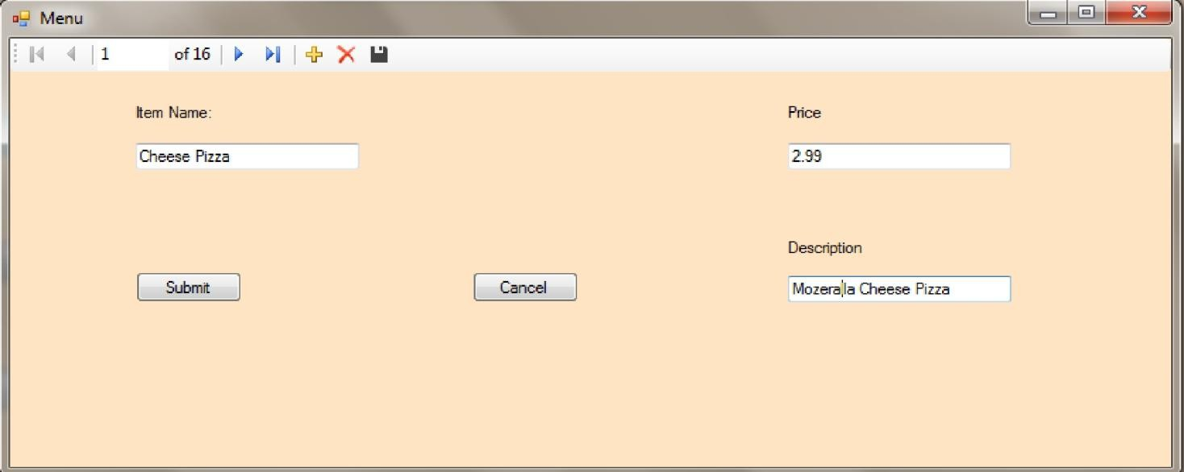

**FIGURE 3.0: Adding new menu food item.**

**4.4.2: Delete a menu items:** The below is the interface to delete the menu items from application as shown in the figure 3.1. Manager or supervisors can delete the unwanted menu items from the application by selecting the item name and checking other respective description of the item.

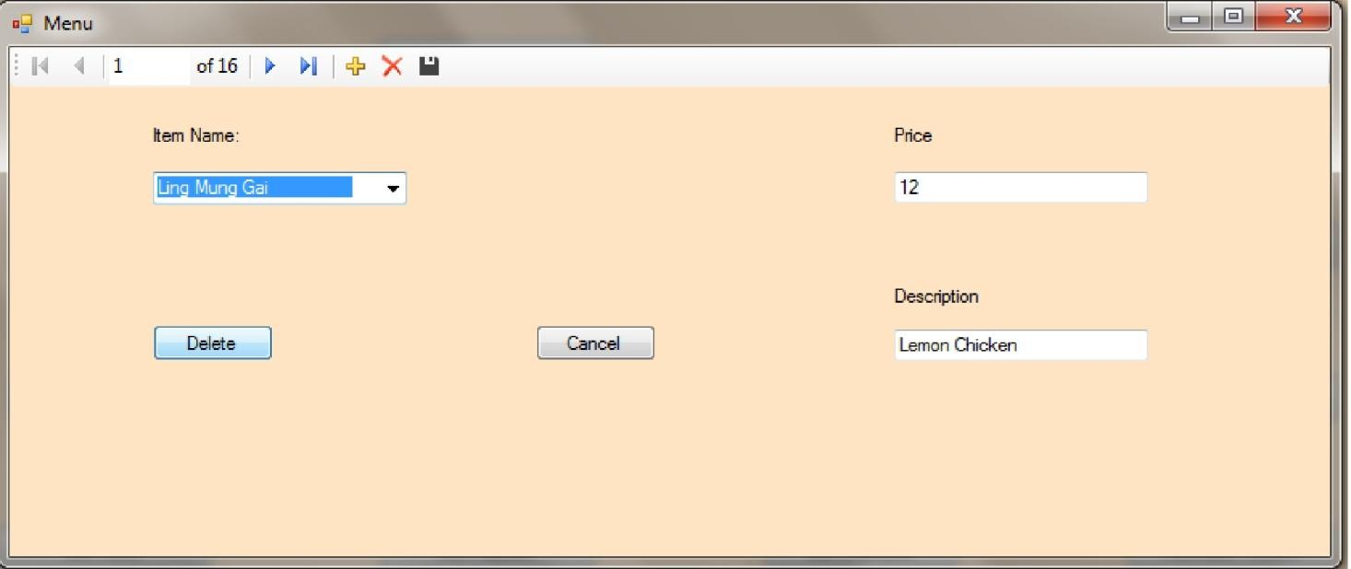

**FIGURE 3.1: Delete food menu item.**

**4.4.3: Edit a menu items:** The below is the interface to edit the menu items from application as shown in the figure 3.2. Manager or supervisors can edit the menu items from the application by selecting the item name and modify the price, description or item name.

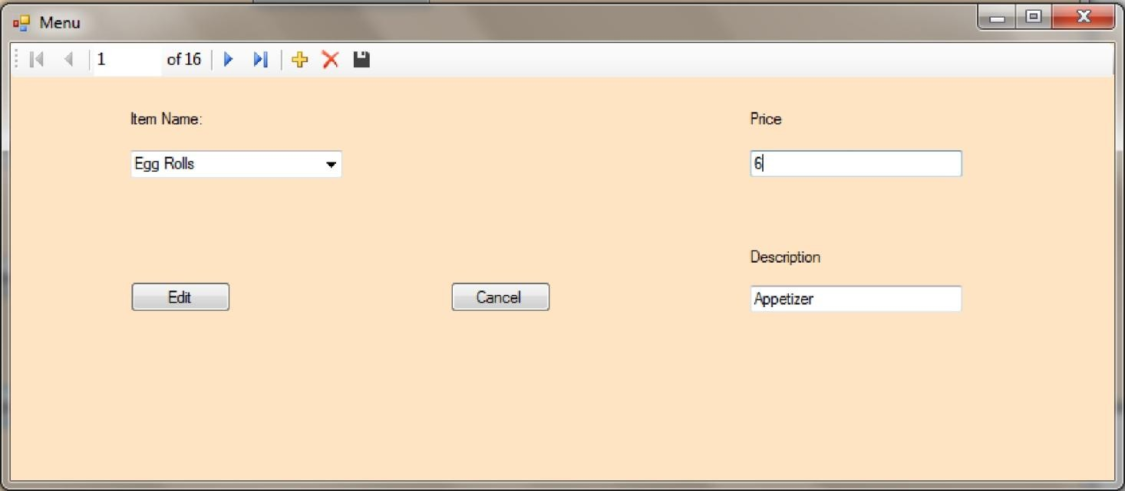

**FIGURE 3.2: Edit food menu item.**

**5.5 Managing suppliers – Add, Delete and Edit Suppliers**

In our application we keep track of the Supplier`s, it supports adding new supplier details in to the application, edit the supplier details and deleting the supplier details as needed.

**5.5.1: Add new Supplier details items:** The below is the interface to add the new supplier details to the application as shown in the figure 4.0. Manager or supervisors

can add the new menu item with the details like supplier`s name, supplier`s address and supplier`s phone number.

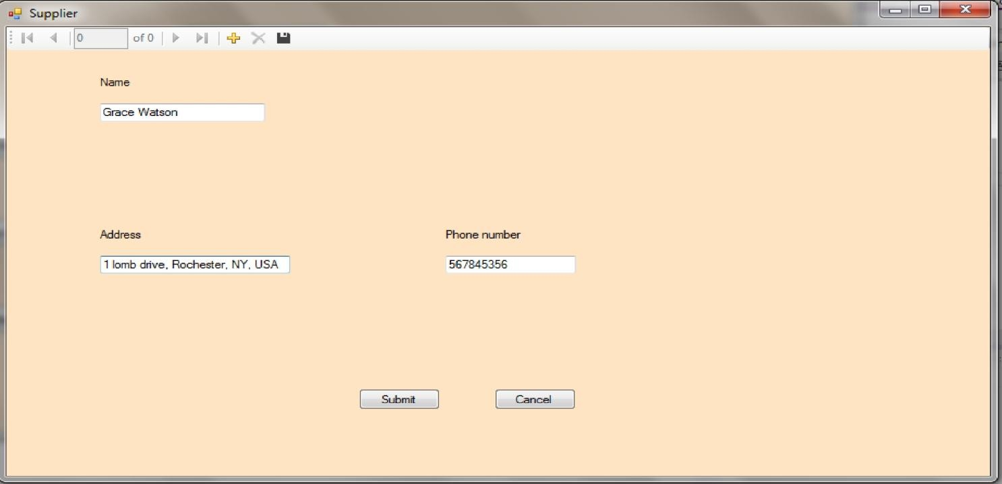

**FIGURE 4.0: Adding Suppliers**

**5.5.2: Delete the Supplier items:** The below is the interface to delete the Supplier`s

items from application as shown in the figure 4.1. Manager or supervisors can delete the unwanted supplier details from the application by selecting the supplier`s name and cross checking the address and phone number.

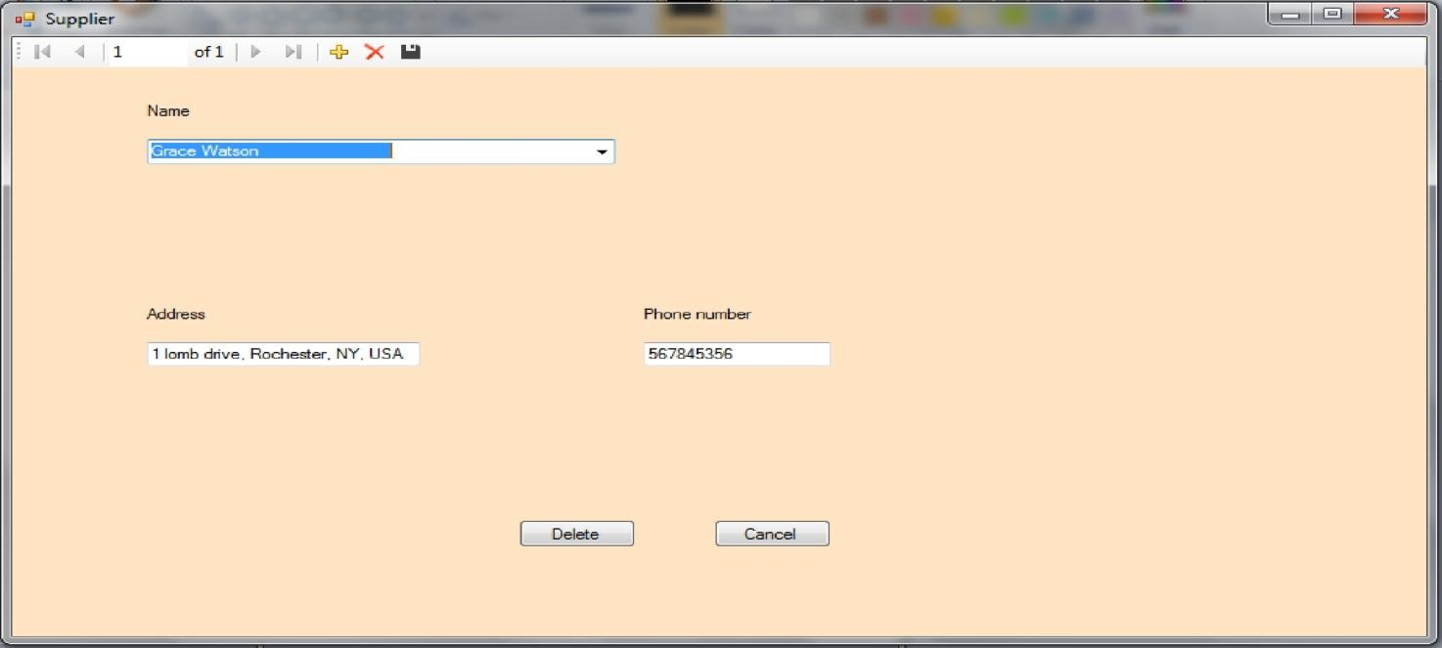

**FIGURE 4.1: Deleting Suppliers**

**5.5.3: Edit the Supplier`s details:** The below is the interface to edit the Supplier`s details from application as shown in the figure 4.2. Manager or supervisors can edit the supplier`s details from the application by selecting the supplier`s name and cross verifying the supplier`s respective address and phone number.

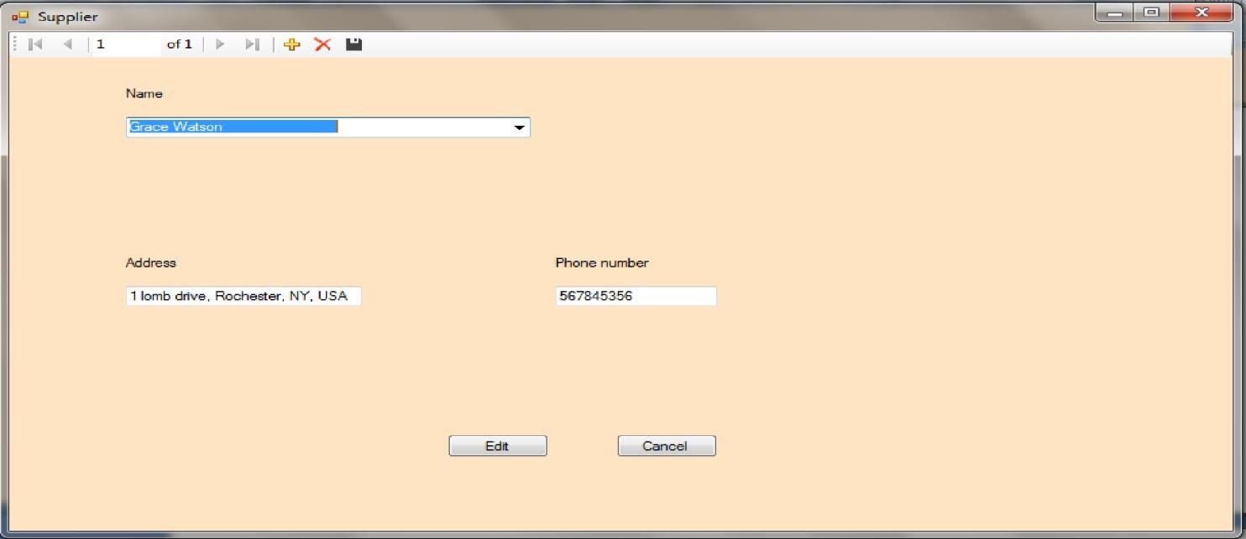

**FIGURE 4.2: Editing Suppliers**

**5.6 Employee Management – Add, Delete and Edit Employee details**

In our application we keep track of the Employee management, it supports adding new employee details in to the application, edit the employee details and deleting the employees details as needed.

**5.6.1: Add new employee details:** The below is the interface to add the new employee details to the application as shown in the figure 5.0. Manager or supervisors can add the new employee details with the details like employee`s name, employee`s address, phone number, Salary per hour rate.

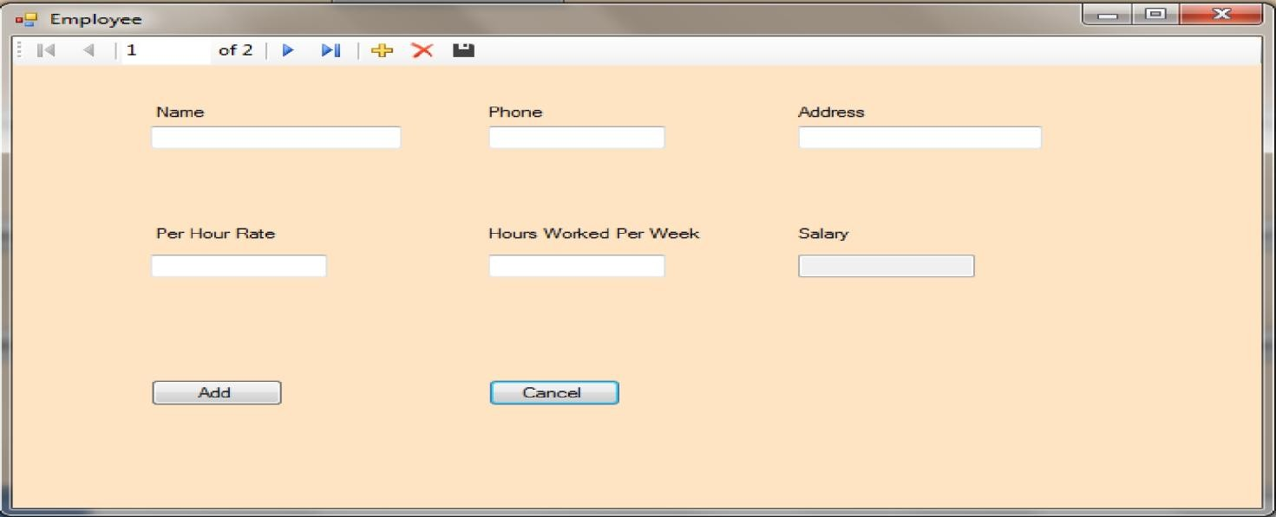

**FIGURE 5.0: Adding new Employee details**

**5.6.2: Delete the Employee details:** The below is the interface to delete the employee`s details from application as shown in the figure 5.1. Manager or supervisors can delete the unwanted employee`s details from the application by selecting the employees’ name and cross checking the address and phone number.

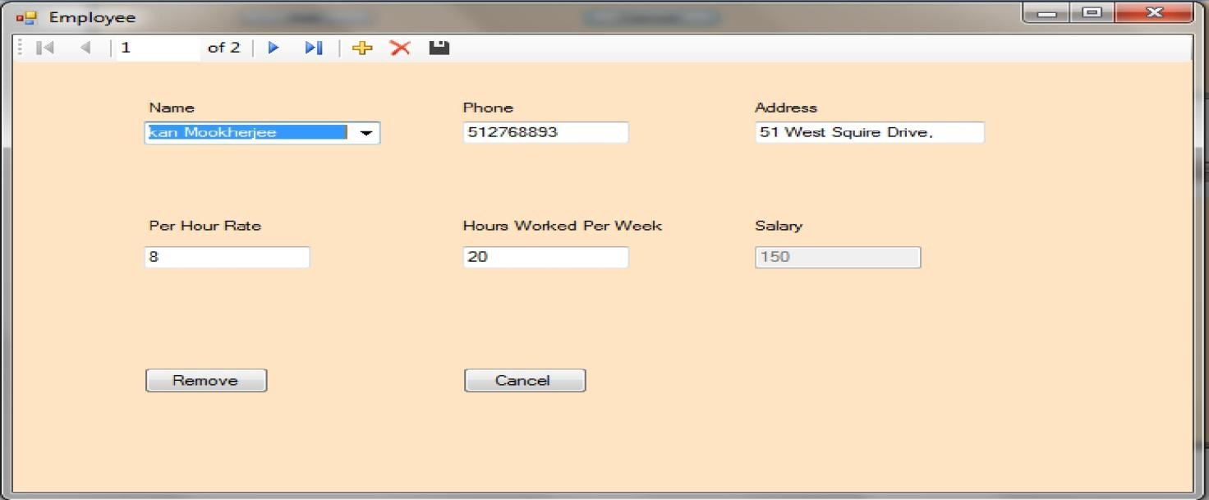

**FIGURE 5.1: Delete Employee details**

**5.6.3: Edit the Employer’s details:** The below is the interface to edit the Employer’s details from application as shown in the figure 5.2. Manager or supervisors can edit the Employer’s details from the application by selecting the Employer’s name and cross verifying the Employer’s respective address and phone number.

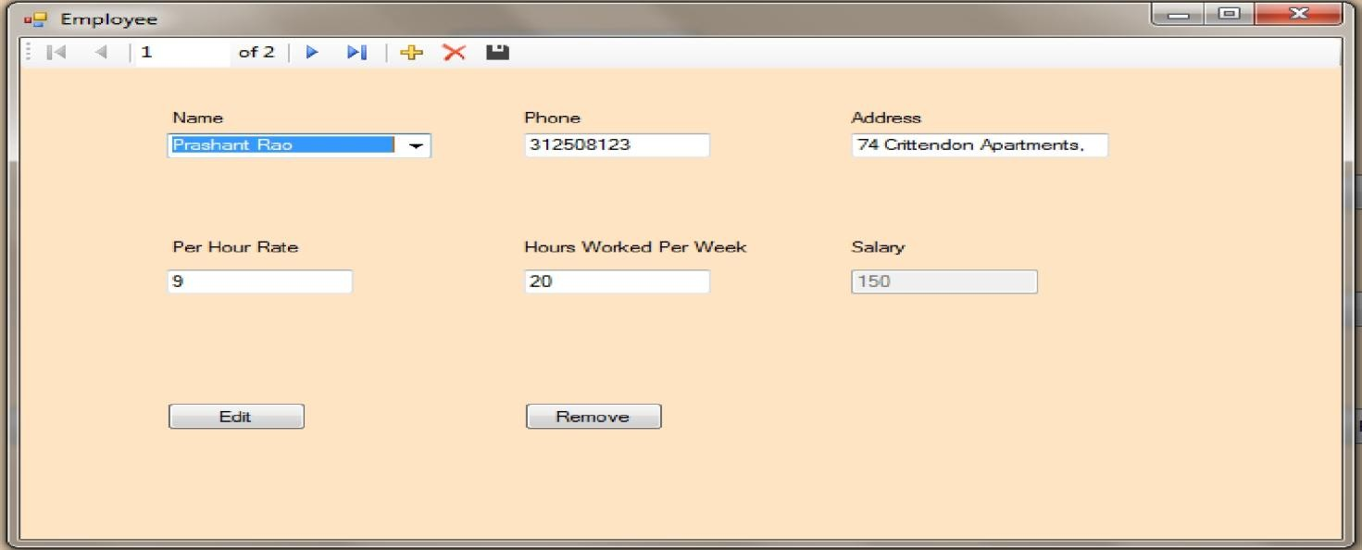

**FIGURE 5.2: Edit Employee details**

**5.7 Product Management – Add, Delete and Edit Product details**

In our application we keep track of the product management, it supports adding new product details in to the application, edit the product details and deleting the product details as needed.

**5.7.1: Add new product details:** The below is the interface to add the new product details to the application as shown in the figure 6.0. Manager or supervisors can add the new product details with the details like product`s name, unit, Amount, IblSupplier, Description, and employee name.

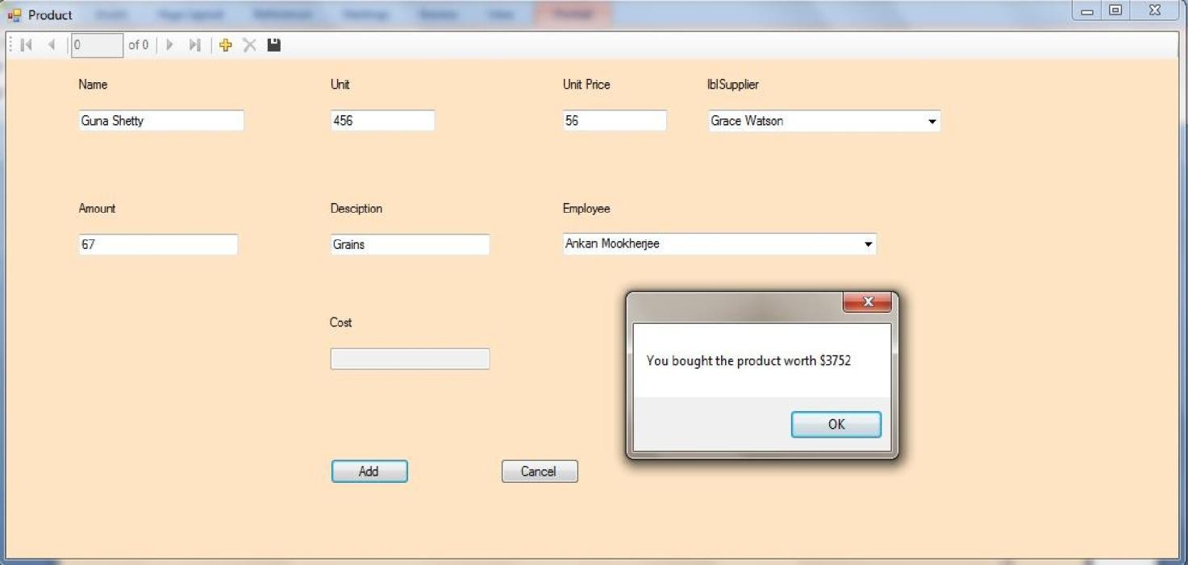

**FIGURE 6.0: Add Product Details**

**5.7.2: Delete the Product details:** The below is the interface to delete the product details from application as shown in the figure 6.1. Manager or supervisors can delete the unwanted product details from the application by selecting the product name.

16

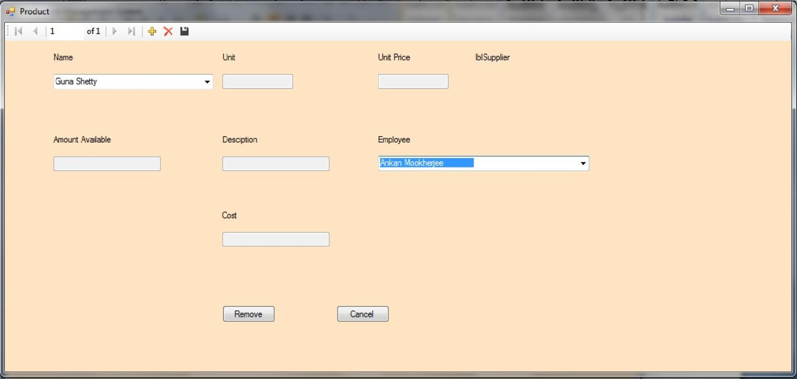

**FIGURE 6.1: Remove Product Details**

**5.7.3: Purchase the Product details:** The below is the interface to add the purchase the Product details from application as shown in the figure 6.2. Manager or supervisors can add the product as shown below to the application.

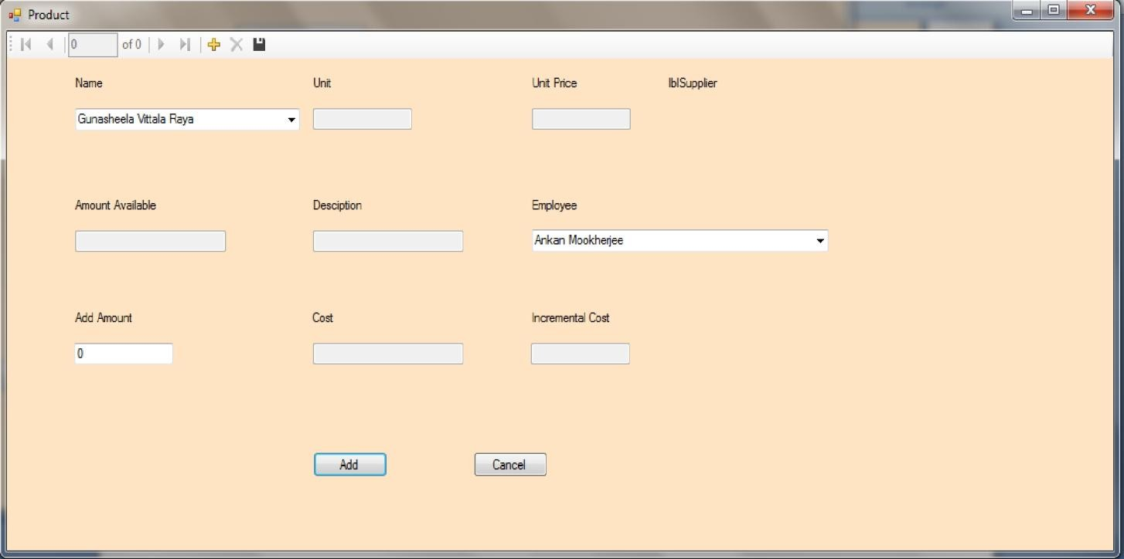

**FIGURE 6.2: Purchase Product Details**

**6.0 TESTING**

For the above application we have performed Black Box Testing and Unit Level Testing as

the components were building across. We have tested formally and informally as part of the development process some of the tests that we ran as part of formal testing is as follows:

**6.1 FRONT END INTERFACE TESTING**

We check the entire interface for the functionality, like the following:

a. Test the interface of the main form and all sub forms for correctly displayed.

b. Check the close, minimize and maximize button works correctly for all windows based forms.

c. Check for syntax errors on the forms, typo`s etc.

d. Check main form is displayed correct with respective color set in the background. e. Check the button of the sub form works when clicked from the main page.

f. Provide invalid input on the form and check, for example by inputting character in place of credit card number text box. Check for correctness.

g. The above tests were repeated for all sub forms as well.

**6.2 BACK END FUNCTIONALITY AND INTERFACE TESTING**

a. Check one the data is entered in the form it is updated in the database. b. Check for data redundancy in the application or database.

c. Checked the data is retrieved properly in all the forms.

d. Checked triggers worked properly when the item in the stock goes below the level set.

**6.3 INTEGRATION TESTING**

a. Tested the combining the both the back end and front end, verified the database to the form connection is proper.

b. Checked over all functionalities by exploring all the options in the random passion using black box testing.

18

**7.0 FUTURE SCOPE**

Currently, the application is a standalone application, this can made an online application accessing it over the internet or local area network. It can also be extended to support the patrons to order the food using the application, digital displays can be placed at the every table so that patron can order the food directly using the touch screens or simple user friendly computers. The patrons need not wait for the waiters to come and pick the order, patrons can also make payments directly using the credit cards or debit cards. The next future of this project would be extended it to a distributed environment where multiple member can accesses the application at the same time and update the records accordingly, the manager or owner of the food management system can sit miles away and keep track of the orders that took place and work virtually from any part of the world. Overall efficient of the restaurant would increase and minimize man power resources.

20